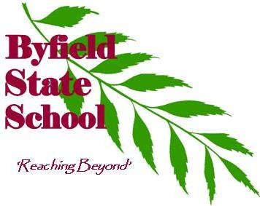
2025 -2026
Uniform Policy
Byfield State School has a Uniform Policy, which has been endorsed by our P&C Association. The Byfield State School community believes that there are benefits in student dress following an agreed code.
These benefits include:
Appropriateness – to ensure that all students are dressed appropriately for all school activities
Safety – to make student identification easier in the school grounds, whiled travelling to and from school and on excursions
Equity – to discourage fashion competition eg. wearing brand names
Expense – to minimise the cost to families
Identity – to develop in students a sense of belonging and pride in their school.

Uniforms are available from the school on Monday and Friday from 8;15am – 9am.

Our school uniform consists of:
Clothing | - A Byfield State School Polo shirt  - Plain maroon shorts or skorts  - A plain maroon jumper or zipped jacket (Winter)  - Plain maroon tracksuit pants (Winter)  - Senior shirt (Year 6 students)  Kindy  - A Byfield Kindy shirt  - An orange Kindy hat (provided by Education Queensland)  - Plain maroon shorts or skorts
Sunsafety | - Byfield School Hat or a plain maroon bucket hat  - Swim shirts must be worn for swimming lessons  - The school also supplies sunscreen which is located in classroom areas and maintains a ‘no sun-safe hat, no outside play’ rule.
Jewellery | Maximum allowable item  - Watch (Smartwatches that can be used as a mobile device are NOT permitted at school  - One pair of small studs or sleepers in ear lobe only.  - One necklace for religious, cultural or medical reasons only.  - No rings, bracelets or anklets
Hair | - Tied back at all times if hair is longer than collar length – boys and girls.  - Hair to be ‘natural’ hair colour.  - Hair style should be conservative, neat and tidy or as deemed appropriate by the Principal  - Hair accessories should be conservative
Footwear | - Plain closed-in shoes/joggers – lace up or Velcro (NB slip on shoes are not appropriate) with plain white or black ankle or crew length socks.  No child will be allowed to access the general playground areas without appropriate enclosed footwear. Footwear may be removed in classrooms (at the discretion of the teacher) and to access the sandpit and mud play areas.
Cosmetics | - No make-up, nail polish or artificial nails.  - Any other item for medical reasons only.
Free Dress Days | - Dress must be Sun Smart at all times  - No inappropriate logos, slogans or wording.  - Fully closed in footwear.

